Abdul-Munim Al-Rubaie 2
Managing Partner 2
Fouad Al-Bitar 4
Audit Partner 4
Ousama Alani 5
Business Consultancy Partner 5
Mohammad Hejmadi 6
Senior Audit Manager 6
Syed Irfan 7
Audit Manager 7
Rency Escalante 8
Audit Manager 8
Ibaa Waheed 9
Audit Manager 9

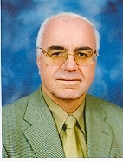 | Abdul-Munim Al-Rubaie  (Dr. Munim)  Managing Partner

Memberships | - Member of the Institute of Chartered Accountants in England & Wales - England  - Associate Member - 1971 to 1979  - Fellow Member - 1979 to current  - Representative of Brandenburg Government (Germany) in the United Arab Emirates – UAE - 2006 to 2007  - Chairman of the Iraqi Business Council in Dubai & Northern Emirates – UAE - 2006 to 2008  - Registered Agent for Offshore Companies in JAFZA – UAE  - Registered in the UAE Arbitration Centers in Abu Dhabi & Dubai & Bahrain as Expert as Arbitrator & Conciliator – UAE  - Member of the UAE Auditors & Accountants Association – UAE
Professional Info | Fields of Expertise  - Accounting  - Auditing  - Management  - Business Development  Worked since 1968 in the fields of accounting, auditing, management, and teaching.  Titles held are Articled Clerk, Chartered Accountant, Consultant, Managing Partner & Supervisor, Chief Accountant, Professor, Supervisor, and Principal Partner.  Companies employed in are Robson Rhodes (Deloitte, Chartered Accountants), and National Bank of Abu Dhabi.  Company owned is Al-Janabi & Al-Rubaie & Co. Chartered Accountants.  Institutions served for are Iraqi Business Council, Ministry of Justice, Abu-Dhabi Commercial Conciliation & Arbitration Centre, Dubai Commercial Conciliation & Arbitration Centre, Gulf Commercial Conciliation & Arbitration Centre, Mustansiriyah University, Higher Colleges of Technology, UAE University, Board of Financial Control, Ministry of Finance.  Countries employed in are Iraq, England, and UAE.
Educational Info | - Certificate from Institute of Chartered Accountants England &  Wales - 1971  - Bachelor of Commerce (Honors) in Accounting – Leeds  University - Leeds, England – 1968
Personal Info | Birth Date: 1944  Places Lived: Iraq, England, Jordan, Canada, and UAE.  Traits: diligent, meticulous, principled, open-minded, visionary.  Hobbies: dominoes, walking, swimming, news.

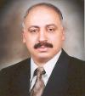 | Fouad Al-Bitar  (Mr. Fouad)  Audit Partner

Memberships | Member of the Arabic Institute for Accounting & Auditing – Iraq.
Professional Info | Fields of Expertise  - Accounting  - Auditing  - Sales  Worked since 1981 in the fields of accounting, auditing, administration, and sales.  Titles held are Accountant, Contractor, Salesman, Auditor, and Teacher.  Companies employed in are Cyprus Company for Engineering Electrical & Mechanical Services, Barody & Awad Company, and Sabah Mohammad Ali Al-Shindah Office.  Countries employed in are Iraq, Jordan, and UAE.
Educational Info | - Certificate of Arabic Chartered Accountant - Arabic Institute for Accounting & Auditing - Iraq - 1995  - Bachelor of Commerce in Accounting- Mustansiriyah University - Baghdad – 1981
Personal Info | Birth Date: 1956  Places Lived: Iraq, Jordan, and UAE.  Traits: communicative, friendly, open-minded, diligent.  Hobbies: TV shows, news.

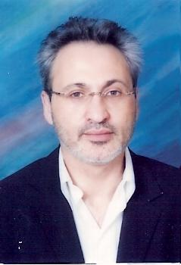 | Ousama Alani  (Mr. Ousama)  Business Consultancy Partner

Memberships | Vice-President of IBC (Iraqi Business Council) Dubai & Northern Emirates (an extension of the Dubai Chamber of Commerce & Industry) – UAE.
Professional Info | Fields of expertise  - Finance  - Management  - Business Development  Worked since 1989 in the fields of marketing, finance, management, and consultancy.  Titles held are Consultant Country Manager, Entrepreneur, Marketing and Media Consultant, Business Development Manager, and Business Development & Marketing Manager.  Companies employed in are International Public Relation, Interkey Saudi Arabia, Iraq Gulf Holding, and Merchant Bridge Bank.  Company owned is Global Telecom.  Countries employed in are Canada, England, and all over the Middle East.
Educational Info | Bachelor of Arts in Business Administration and Economics – Bishops University - Quebec, Canada – 1988.
Personal Info | Birth Date: 1962  Places Lived: England, Canada, Bahrain, Saudi Arabia, Iraq, and UAE.  Traits: open-minded, adaptable.

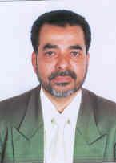 | Mohammad Hejmadi  (Mr. Hejmadi)  Senior Audit Manager

Memberships | Member of ICWA (Institute of Cost and Works Accountants of India) – India - 1975 to current.
Professional Info | Fields of expertise  - Auditing  - Accounting  Worked since 1970 in the fields of accounting, auditing, and management.  Titles held are Accountant, Duty Manager, Accounts Controller, Group Chief Accountant, and Chief Accountant.  Companies employed in are Bank of Baroda, Kaiksaw Group, Falcon Financial Management Consultant, Taj Group, and AI-Hidava Travel & Tourism.  Countries employed in are India, Bahrain and UAE.
Educational Info | - Cost Accounting - Institute of Cost & Works Accountant of India (ICWA) - 1975  - General Law – 1974  - Bachelor of Commerce in Auditing & Costing – Mysore University - Karnataka, India – 1970
Personal Info | Birth Date: 1950  Places Lived: India, Bahrain, and UAE.  Traits: diligent, principled.

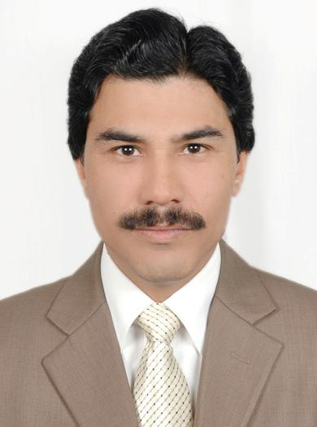 | Syed Irfan  (Mr. Irfan)  Audit Manager

Memberships | N/A
Professional Info | Fields of expertise  - Accounting  - Auditing  Worked since 1997 in the fields of accounting and auditing.  Titles held are Accountant, Internal Auditor, Chief Accountant, and Senior Auditor.  Companies employed in are Noon Textile Mills Limited, Neelibar Group of Companies, Medi Cas International, Tetra Pak Middle East, Gulf & Safa Dairies, and HES Chartered Accountants.  Countries employed in are Pakistan and UAE.
Educational Info | - Masters of Business Administration in Finance - Al-Khair University - Peshawar, Pakistan - 1997  - Bachelor of Arts in Economics - Islamia College - Peshawar, Pakistan - 1992
Personal Info | Birth Date: 1971.  Places Lived: Pakistan, UAE.  Traits: principled, diligent.  Hobbies: horse-riding.

 | Rency Escalante  (Mdm. Rency)  Audit Manager

Memberships | - Member of Certified Public Accountants – Philippines  - Member of Philippine Institute of Certified Public Accountants  (PICPA) - Philippines  - Member of Junior Philippine Institute of Accountants - Philippines  - Member of Finance Society  - Member of Association of Tax and Law Students
Professional Info | Fields of expertise  - Accounting  Worked since 2005 in the field of accounting.  Title held is Junior Accountant.  Company employed in is Asia Insurance (Philippines) Corporation.  Country employed in is Philippines.
Educational Info | - Bachelor of Science in Accounting - University of the East Philippines - Philippines  - Certificate in CPA (Certified Public Accountant) – Philippines  - many seminars / courses attended
Personal Info | Birth Date: 1983  Places Lived: Philippines

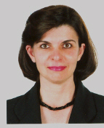 | Ibaa Waheed  (Mdm. Ibaa)  Audit Manager

Memberships | Member of the General Union of Arab Accountants and Auditors.
Professional Info | Fields of expertise  - Accounting  - Auditing  Worked since 1980 in the fields of accounting, auditing, and teaching.  Titles held are Auditor, Financial Auditor Assistant, Financial Auditor, Senior Financial Auditor, and Lecturer.  Company employed in is Board of Supreme Audit and Ministry of Higher Education and Scientific Research.  Country employed in is Iraq.
Educational Info | - Higher Diploma in Financial Auditing - Baghdad University -Baghdad, Iraq - 1988  - Bachelor in Accounting & Business Administration - Al Mustansiriyah University – Baghdad, Iraq – 1980
Personal Info | Birth Date: 1958  Places Lived: Iraq, UAE.  Traits: communicative, principled, and generous.  Hobbies: drawing, puzzles, movies.

